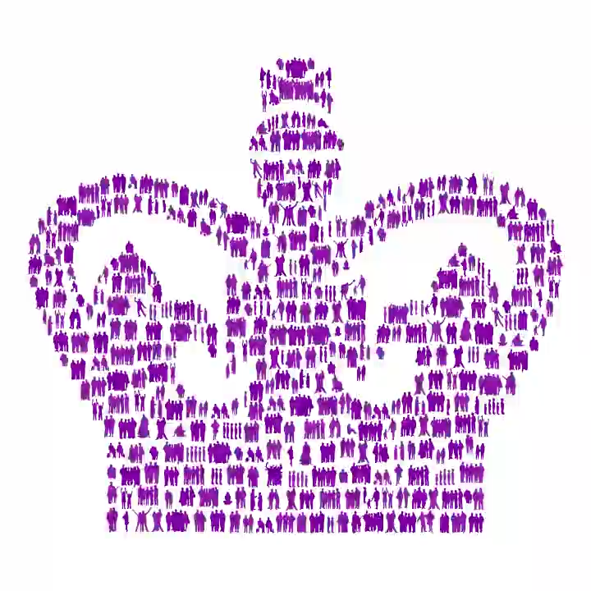
(Click to view animation)

KentARA is awarded the The King’s Award for Voluntary Service (KAVS)

This is the highest award given to local volunteering groups in the UK. Equivalent to an MBE, The KAVS is awarded for life.
Formerly The Queen’s Award for Voluntary Service, the KAVS honours the very best of local voluntary groups, showcasing how they create a positive impact in their communities.
Ian Sharp, KentARA Chairman, said “I am pleased to announce that KentARA have been graciously awarded the Kings Award for Voluntary Service (KAVS) (MBE) for all the hard work that has been put in by all 76 Club Committees and the KentARA Committee”
The award was made on the King’s birthday, 14th November 2025 to 231 groups and organisations nationwide of which 7 are in Kent, with the notation for KentARA “Operating local clubs for retirees to alleviate loneliness and social isolation”.

