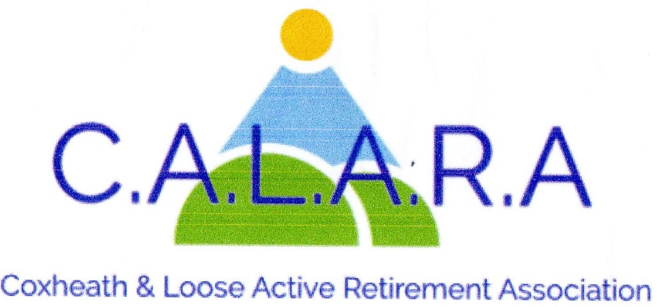
www.calara.org.uk

CALARA NEWSLETTER NOVEMBER 2025

TODAYS ENTERTAINER- JUDY KNIGHT will be talking about 'How our forebears coped with make do or mend' Her talk is both amusing and equal interest to both ladies and gents.

CHRISTMAS FESTIVE AFTERNOON TEA- 12th December.
We still have a few spaces left for our party so please see Sheila Scott in the tea break to put your names down and pay your £10.00 (cash preferred). If you have already have your name on the list but have not yet paid please also see Sheila.

MEMBERSHIP- Chris Coleman
Will today's new members see me during the tea break in the small hall where I will collect their money and forms and give them their new membership cards. Chris Coleman 01622 744041.

CRAFT- Chris Coleman.
Please take the opportunity to get your hand made Christmas cards from us in the small hall. We would like more members to come along and join us on Friday afternoons 2.00pm-4.00pm. We are a friendly crowd who laugh and chat a lot as well as doing knitting or craft. It is a most enjoyable afternoon with tea and biscuits at 3.00pm. A tonic to set you up for the weekend. So do come along and see for yourselves, you are all very welcome.
Please note there will be no craft class on Friday 14th November due to the Thursford outing on the day before. Chris Coleman 01622 744041

MONDAY MOVERS- Barbara Lowe- Monday mornings.
There are two sessions at 10.00am and 11.00am in the small hall. This still continues to be very popular with new members joining. Barbara Lowe 01622 296863.

SHORT MAT BOWLS- Chris Frost- Tuesday afternoons.
In a break with tradition now that the clocks have changed the timings have been altered. We now start and finish earlier and would ask members to arrive in time to start playing at 2.00pm. We will finish at 4.00pm.
This is a social afternoon and new members are welcome, even if you have not played before. So why not come along and try it out. Equipment can be supplied. Chris Frost 01622 745908.

CRIBBAGE- Gwen Hawkes Monday afternoons.
We meet in the Committee room on Monday afternoons, except Bank Holidays between 2.00pm-4.00pm. The cost is £2 including refreshments. Because of limitations in the Committee room I have had to close the list. I have a reserve list so contact me if you are interested.01622 746847.

WHIST- Gwen Hawkes- Wednesday afternoons.
We meet in the Committee room on Wednesday afternoons 1.00pm-3.30pm. The cost is £3.50 which includes refreshments, raffle and whist prizes. New members always welcome.
Gwen Hawkes- 01622 746847.

SOLITAIRE- Sheila Rosier.
We are a small group for members on their own. We meet on 2nd Tuesday of the month in the committee room for a cup of tea and a chat and to arrange trips out.
Please contact me in the first instance. Sheila Rosier 01622 746459

HOLIDAY – Cliff Burke
Regarding the holiday to Torquay next June, the travel company and the Hotel have finally agreed to release 13 more double rooms for single use. This is dependent on finding a number of couples to take another eight double rooms and to part fill two coaches. If any additional members would be interested, or if you have friends or family members who would like to join you, please let me know. If we achieve this, (I am optimistic we will) there will be a nominal supplement on all Single rooms, which is usually the norm. We have seven months to go!!
Note – Cliff will not be at the meeting today but can be contacted next week on 07931 691934

DAY TRIPS – Carole Burke
Thursford 13.11.25.
A reminder that the coach will arrive at around 7.30am for a departure at 7.45am. We should arrive in plenty of time to have some lunch and a look around before our 2pm performance and then to Best Western Hotel, Kings Lynn for dinner and our overnight stay. I do hope you will enjoy!
I am processing refunds due for those unable to make Buckingham Palace and Thursford. As I am unable to attend the November meeting these will all be available for you to pick up at the December meeting.
I already have some ideas for 2026 but if you have any suggestions, please let me know.
Carole. 07736104764/email: carole.chapman@hotmail.co.uk

LUNCHES - - Val Allan and Val Cole
We had a wonderful lunch at The Woolpack last time, everyone thoroughly enjoyed home cooked food. Beautiful little pub/restaurant great surroundings great service. That is a must to go back to next year.
Our next lunch is on November 27th it’s a Christmas special lunch at The Plough one of our favourites we think you might agree. We will be displaying a few menus on our table please come and look at it as it is full of yummy Christmas food we are sure you will agree. Some of you have been before to a Christmas lunch there and we hope you will come and enjoy another one there with us. Please bring a £10.00 deposit with you as requested by The Plough, cash preferably but cheque acceptable also it’s the usual start time. We will have to pay the deposit the next day or the Monday at the latest so please have it or get it to us asap. The run up to Christmas is already getting very busy so we (the 2 Vals wish you all the very best) looking forward to taking your bookings for a great lunch at The Plough
Thank you for your support in organising and enjoying some great different venues please tell us your favourite so we can keep them on the list for next year The Plough and the Woolpack will be first and second on the list.
Looking forward to seeing you all there Contact number 07749 869387

NEXT MEETING – FRIDAY 5TH DECEMBER
Our Entertainer next month is Simon Mott, who is telling us "What makes a Superstar"
This is a fascinating talk, where there is a wonderful twist in the tale!!
I will say no more and wait to be surprised on the day!

