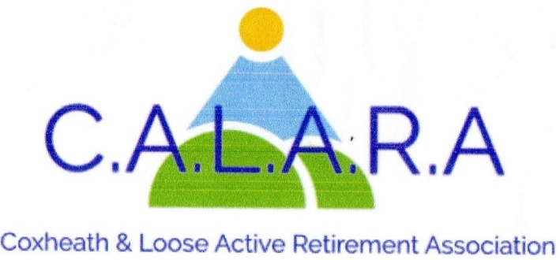
A member of KentARA www.calara.org.uk

CALARA NEWSLETTER JANUARY 2026
A message from your Chairman. I’m hoping you have all enjoyed a happy Christmas and a good New Year. Sending everyone best wishes for 2026 which we will all do our best to ensure a happy, safe and healthy time for all our members. Ann Perriman

TODAY'S SPEAKER
Our speaker is Mary Smith, who will be telling us about the "Secret Tunnels of Maidstone Grammar School

MEMBERSHIP - Chris Coleman
Will the Associate members who are here today please see Chris in the small hall during the tea break to fill in a membership form so they can be transferred to a Full membership status. They will not be asked to pay anything until April when everyone else pays their yearly subs. They can also collect a new card to inform them of the speakers up to the end of our year. Chris Coleman 01622 744041

ANNUAL SUBSCRIPTIONS
Our Annual Subscriptions were reduced from £8 to £5 in 2019. We are facing increased costs in many areas such as hall rent, speakers and general expenses and after much discussion in committee, it has been decided that as from April, our annual subscription will revert to £8.00 per person. This will apply to all members as we have also taken a decision to discontinue Associate Membership.
We would still have the lowest fees of the ARAs in surrounding areas and we hope members would support us and renew in April at the new rate.

CRAFT- Chris Coleman.
The craft group return on the Friday 16th January in the small hall from 2.00pm to 4.00pm. We are hoping to start the New Year with a spring clean. Over the years we have collected such a lot of equipment etc., which needs to be sorted, so we are taking the opportunity to start the New Year with a clear cupboard.

NEW
Several members have shown an interest in playing board games such as scrabble etc. So I have decided to turn one corner of the craft room into a games area on a Friday afternoons to see how it goes. To start with you will need to bring your own board games to see what sort of games you like to play. We are hoping to start this on Friday 13th February. If you are interested please call me on 01622 744041 and let me what you think. Chris Coleman

MONDAY MOVERS- Barbara Lowe- Monday mornings.
After the fun and games and eats it will be back to fun and exercise. Monday Movers started on the 5th January and is now up and running on Mondays with 2 classes - 10.00am and 11.00am. New joiners welcome and please book with Barbara Lowe 01622 296863.

SHORT MAT BOWLS- Chris Frost- Tuesday afternoons.
Bowls started on Tuesday 6th and a reminder that we ask members to arrive at 2.00pm in time to start playing at 2.15pm. We will finish at 4.00pm.
This is a social afternoon and new members are welcome, even if you have not played before. So why not come along and try it out. Equipment can be supplied. Chris Frost 01622 745908.

CRIBBAGE- Gwen Hawkes Monday afternoons.
We meet in the Committee room on Monday afternoons, except bank holidays between 2.00pm-4.00pm. The cost is £2.00 including refreshments. Because of limitations in the Committee room I have had to close the list but I have a reserve list so contact me if you are interested. Gwen Hawkes 01622 746847

WHIST- Gwen Hawkes- Wednesday afternoons.
We meet in the Committee room on Wednesday afternoons 1.00pm-3.30pm. The cost is £3.50 which includes refreshments, raffle and whist prizes. New members always welcome.
Gwen Hawkes- 01622 746847.

SOLITAIRE- Sheila Rosier.
We are a small group for members on their own. We meet on 2nd Tuesday of the month in the committee room for a cup of tea and a chat and to arrange trips out. Our January meeting
is on the 13th. Please contact me in the first instance. Sheila Rosier 01622 746459

HOLIDAY – Cliff Burke
Regarding the holiday to Torquay on 8th June, I imagine once Christmas is over, people will start thinking about holidays!! As mentioned before, double and twin rooms are up for grabs, so contact Cliff or Carole if you would like to join us. I have had nothing but good reports about the venue…...it will indeed be a good holiday! Cliff Burke 07931 691934

DAY TRIPS – Carole Burke
I have arranged an afternoon tea at Mote House on Thursday 29th January for 2pm (there is no Calara lunch in January). It will be £27 including tip. Own transport, but let me know if you need a lift. There is a buggy available to take you down from the car park - please let me know if this is required and any allergies/food preferences. Payment required in full please at the January meeting - cheques made payable to Calara.
I will announce shortly some proposed trips for 2026. Suggestions always welcome.
Regards. Carole Burke 07736101764

CATERING – Sheila Rosier
We need help from members to take a turn washing up the cups and saucers after tea has been served at the monthly meetings. There is a rota on our CALARA notice board. Two people are needed each month, so if you can please help put your name down. This would be much appreciated by the ladies who make and serve the tea each month. Sheila Rosier 01622 746459

LUNCH NEWS - Val Allan and Val Cole
Good afternoon one and all. Happy New Year to everyone. We have no lunches this month and are looking at our next venue for February (possibly) weather permitting. We will let you all know in due course where we will be going. In the meantime stay warm stay safe stay healthy out of the January chills.
The 2 Vals

NEXT MEETING – FRIDAY 6TH FEBRUARY
We have musical entertainment from Jayne Snow.
Jayne is a fabulous singer, and well known in Kent. A nice mixture of modern and classic hits, and lovely afternoon of entertainment is promised.

