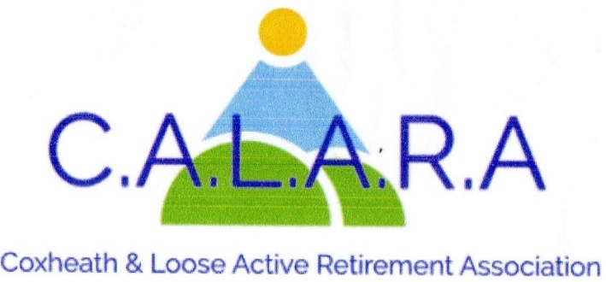
A member of KentARA www.calara.org.uk

CALARA NEWSLETTER FEBRUARY 2026

A MESSAGE FROM YOUR CHAIRMAN
As you know in April we elect our Committee and Officers for the year. I took the role of Chairman two years ago when Dave was unable to continue but I did indicate that after ten years of organising the holidays, I really didn't want to be active in the future. Therefore I will be standing down as Chairman from April. I have been amazed at the support you have all given me and I'm sure we will continue this support to whoever takes over. Many thanks to you all. Ann.

TODAY'S ENTERTAINER- We have musical entertainment from Jayne Snow, a fabulous singer who is well known in Kent. A nice mixture of modern and classic songs.

MEMBERSHIP- Chris Coleman.
Any member who is attending for the first time today please see me in the small hall during tea break with their completed membership form. I will then issue them with a new card with details of of entertainers up to April's AGM. Everyone will be asked to pay their yearly membership money for the following year.

CRAFT- Chris Coleman.
The craft group meet here on the 2nd 3rd and 4th afternoons in the month 2.00pm-4.00pm. All members are welcome to come along and enjoy a pleasant afternoon trying new crafts along with chats and laughs making it a most enjoyable afternoon. Tea and biscuits included.
NEW. I am starting a new activity on Friday 13th February 2026 (next week) here in the small hall. If you are interested in board games such as Scrabble etc. or card games (no gambling please) so do come along. It would help if you bring your own games or cards with you to start with so that we can see what will be needed. Contact me on 01622 744041 for further information. Look forward to seeing you.

MONDAY MOVERS – Barbara Lowe- Monday mornings.
There are two classes on Monday mornings in the small hall at 10.00am and 11.00am. Please note there will not be a class on Feb. 16th as Catherine is on holiday. Contact Barbara on 01622 296863.

CRIBBAGE- Gwen Hawkes - Monday afternoons.
We meet in the Committee room on Monday afternoons, except bank holidays between 2.00pm and
4.00pm. The cost is £2.00 including refreshments. Because of limitations in the Committee room I have had to close the list but I have a reserve list so contact me if you are interested.
Gwen Hawkes 01622 746847.

WHIST – Gwen Hawkes - Wednesday afternoons.
We meet in the Committee room on Wednesday afternoons 1.00pm-3.30pm. The cost is £3.50 which includes refreshments, raffle and whist prizes. We are in desperate need of new members, if you haven't played for years or would like to learn, no problem. It's a social, light hearted afternoon. It’s a way to meet new friends and have a game of cards, so come along and see for yourself. Contact Gwen Hawkes 01622 746847 or leave a message if not there or text 07925 974543.

SHORT MAT BOWLS -Chris Frost- Tuesday afternoons.
We ask members to arrive at 2.00pm in time to start at 2.15pm. We will finish at 4.00pm. New members always welcome and equipment can be supplied. Chris Frost 01622 745908.

SOLITAIRE- Sheila Rosier.
We are a small group for members on their own. We meet on 2nd Tuesday of the month in the Committee room for a cup of tea and a chat and to organise trips out.
Please contact Sheila in the first instance. 01622 746459.

LUNCHES – Val Allan and Val Cole
Hello everyone. A New Year some new venues for lunch. Kicking off with The Bull East Farleigh on Feb 26th at 12.15- 12.30. We had a test lunch here a week or so ago absolutely lovely new owners. This comes highly recommended by Chris Cole and others. A new chef makes everything herself all homemade. So the price is small dishes £15 for 3 courses and £20 for medium courses. Wow that’s reasonable. Starters include (fav yum) Prawn cocktail, Breaded Brie + 3 others. Mains Course Chicken and leek pie, Liver and Bacon, Homemade Lasagne, + other dishes. Desserts remember all homemade, Sticky Toffee Pudding, Apple Crumble, Honeycomb Cheesecake, Pavlova, Chocolate Fudge Cake. Please come and see us in the small hall at tea break. We will have the full menu with us. We can answer all questions then or you can phone me Val Allan on 07749869387. Next month March is at everyone’s favourite The Plough.

HOLIDAYS- Cliff Burke – 07931 691934
We are now actively canvassing the other ARA'S to finally fill the last vacancies we have for Double/Twin rooms on our holiday to Torquay on 8th June. More news to follow.

CATERING- Sheila Rosier
We need help from members to take a turn washing up the cups and saucers after tea has been served at the monthly meetings. There is a rota on the CALARA notice board. Two people are needed each month, so if you can help please put your name down. This would be much appreciated by the ladies who make and serve the tea each month. Sheila Rosier 01622 746459.

OUTINGS- Carole Burke. – 07736 104764
Afternoon Tea 29.1.26. This was enjoyed by all. We had great service and a minibus to take those less able to the car park. Some were suggesting Sunday lunch. It’s not the cheapest, but very good reports and perhaps sometime in the spring. Let me or Val know if you are interested.
Proposed trip to Bletchley Park. Just waiting for confirmation of dates. Hoping to go on Saturday 21.3.26 (lots of volunteers on a Saturday). Around £50.00pp. More details today. Carole

ANNUAL GENERAL MEETING
The Annual General Meeting of the club will be on Friday 10th April 2026. The Committee will stand down and elections will take place. This will be a short form of AGM followed by our entertainment. There is an opportunity for members to express their views and to put forward proposals. If any member would like to do this please put your proposals in writing preferably by email to the Secretary-(secretary.calara@gmail.com) Any suggestions would be welcome and are required to be submitted before the Committee meeting on the 11th March. We are always on the lookout for new committee/activity leaders so if you think you could help please contact any committee member. Chris Baker – 07546 114546

NEXT MEETING – FRIDAY 6TH MARCH – CLIFF BURKE
Our Entertainer on the 6th March meeting is our old friend Tony Harris. He is always guaranteed to give us a good laugh, and on this occasion he is MARGARET THATCHER !!! I cannot wait.

