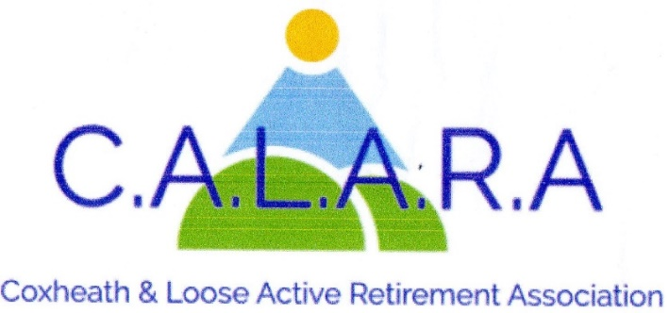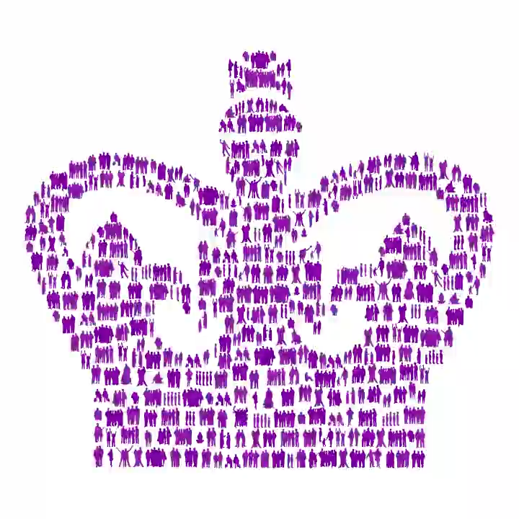
A member of KentARA www.calara.org.uk

CALARA NEWSLETTER DECEMBER 2025

The Chairman and the Committee wish you all a Merry Christmas and a Happy New Year.

TODAY'S ENTERTAINER is Simon Mott who will be telling us “What makes a Superstar”

CRAFT- Chris Coleman.
The craft group is now closed until Friday 16th January 2026. I would like to thank all the ladies who have supported me throughout the year, and wish them a very Merry Christmas and a Happy New Year. We will be selling any last minute Christmas or Birthday cards in the small hall during tea break that you may have forgotten. Over the past 2 months the craft group have raised £89 selling their cards etc. WELL DONE ladies, all the money raised has gone back into CALARA funds. See you and anyone else who would like to join us on Friday 16th January 2026. Chris Coleman 01622 744041

MONDAY MOVERS- Barbara Lowe- Monday mornings.
Monday Movers finishes on Monday December 15th when both classes are together from 10.00am to 11.45am. We restart both classes on January 5th 2026 . If the weather is bad please refer to the website as to whether the class is cancelled. Barbara Lowe 01622 296863.

SHORT MAT BOWLS- Chris Frost- Tuesday afternoons.
Now that the clocks have changed the timings have been altered. We now start and finish earlier and would ask members to arrive at 2.00pm in time to start playing at 2.15pm. We will finish at 4.00pm.
Our last session before Christmas is on 16th December and we resume on the 6th January.
This is a social afternoon and new members are welcome, even if you have not played before. So why not come along and try it out. Equipment can be supplied. Chris Frost 01622 745908.

CRIBBAGE- Gwen Hawkes Monday afternoons.
We meet in the Committee room on Monday afternoons, except bank holidays between 2.00pm-4.00pm. The cost is £2.00 including refreshments. Because of limitations in the Committee room I have had to close the list but I have a reserve list so contact me if you are interested. The last meeting this year is Monday 22nd December and we start again on Monday 5th January 2026. .Gwen Hawkes 01622 746847

WHIST- Gwen Hawkes- Wednesday afternoons.
We meet in the Committee room on Wednesday afternoons 1.00pm-3.30pm. The cost is £3.50 which includes refreshments, raffle and whist prizes. New members always welcome.
Our last session before Christmas is on 17th December and we resume on the 7th January.
Gwen Hawkes- 01622 746847.

SOLITAIRE- Sheila Rosier.
We are a small group for members on their own. We meet on 2nd Tuesday of the month in the committee room for a cup of tea and a chat and to arrange trips out. Our January meeting
is on the 13th. Please contact me in the first instance. Sheila Rosier 01622 746459

HOLIDAY – Cliff Burke
Regarding the Holiday to the Derwent Hotel in TORQUAY next June (Monday 8th)
We are still taking bookings for Double Rooms or Twin Rooms. We are prioritising CALARA members, but are happy to accept members from other "ARA's" and indeed, any friends or family members from our own members. We must facilitate two coaches, so the more the merrier!
I have had wonderful feedback about the Hotel Facilities and Entertainment, and we have some great day trips organised, together with an optional Theatre trip for a Summer Spectacular. I think a good time will be had by all !!! Cliff Burke 07931 691934

DAY TRIPS – Carole Burke
I am trying to arrange an afternoon tea at Mote House on Thursday 29.1.26 for 2pm (there is no Calara lunch in January). I am awaiting confirmation of prices, but it should be £27 including tip, or less if I can get a discount! Own transport, but let me know if you need a lift. I should be able to confirm at the meeting next Friday 5.12. Payment required in full.
I will announce in January some proposed trips for 2026. Suggestions always welcome.
I will have refunds for Buckingham Palace and Thursford today. Carole Burke 07736101764

CATERING – Sheila Rosier
We need help from members to take a turn washing up the cups and saucers after tea has been served at the monthly meetings. There is a rota on our CALARA notice board. Two people are needed each month, so if you can please help put your name down. This would be much appreciated by the ladies who make and serve the tea each month. Sheila Rosier 01622 746459

LUNCH NEWS - Val Allan and Val Cole
Good Afternoon one and all. Val Cole and I hope you have a great meeting today but we are having yet another Xmas meal this time at Hever Castle. Yum. We had a most enormous fantastic meal at the PLOUGH on 27th November, the staff went above and beyond with their service they were
fantastic. The prawn cocktail was out of this world I personally have never had one like it. I think
everyone thoroughly enjoyed the whole experience. Our special thanks to Carol Cooper for making each and everyone a special little gift. The whole day was wonderful, thanks to everyone that could come. So we are having January off and if weather permitting will book a February one and look forward to seeing more of you at the meals in the New Year. If you’re not at the Christmas tea party we hope you have a lovely Christmas with friends and family and wish you all you wish yourselves and look forward to 2026. Best wishes to you all. Val Allan and Val Cole Contact number 07749 869387

NEXT MEETING – FRIDAY 9TH JANUARY
Our speaker for the meeting of 9th January 2026 (NOT the 2nd Jan.....please note.) will be Mary Smith, who will be telling us about the "Secret Tunnels of Maidstone Grammar School".

KentARA is awarded the The King’s Award for Voluntary Service (KAVS)
This is the highest award given to local volunteering groups in the UK. Equivalent to an MBE, The KAVS is awarded for life. Formerly The Queen’s Award for Voluntary Service, the KAVS honours the very best of local voluntary groups, showcasing how they create a positive impact in their communities. Ian Sharp, KentARA Chairman, said “I am pleased to announce that KentARA have been graciously awarded the Kings Award for Voluntary Service (KAVS) (MBE) for all the hard work that has been put in by all 76 Club Committees and the KentARA Committee”
The award was made on the King’s birthday, 14th November 2025 to 231 groups and organisations nationwide of which 7 are in Kent, with the notation for KentARA “Operating local clubs for retirees to alleviate loneliness and social isolation”. We can now use the Award logo.

