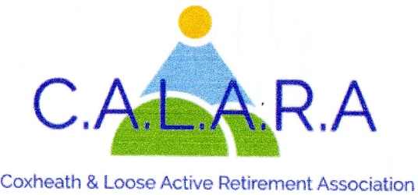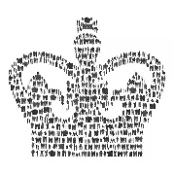
A member of KentARA www.calara.org.uk

CALARA NEWSLETTER APRIL 2026

HAPPY EASTER TO YOU ALL
After the holiday our normal weekly activities resume on Tuesday 7th April with Short Mat Bowls. For the full programme see the Calendar tab

NEXT MAIN MEETING. – FRIDAY 10TH APRIL
This will be short form AGM followed by our entertainer, Nick Kelly (aka Duck soup) an extremely talented singer will be entertaining us. He comes highly recommended.

MEMBERSHIP- Chris Coleman
Gill White and myself will be collecting money for next year’s membership in the Committee room. You can come to either of us. Could you have your membership form ready with the correct money or cheque payable to CALARA (£8.00 pp). We will work as fast as we can, but I would ask you to be patient please. Thanks. Chris Coleman 01622 744041.

CRAFT- Chris Coleman.
The craft group meet here on 2nd 3rd and 4th afternoons of the month in the small hall. We cover many types of paper craft as well as knitting etc. Anyone is welcome to come along and see what we do and join us for a cup of tea about 3pm. We try to make it a social afternoon.

MONDAY MOVERS
Sadly Barbara has had to resign from Monday Movers but we are pleased that Leslie Davies has agreed to take over the class. There are 2 classes at 10.00am and 11.00am in the small hall. New members welcome. On Monday 13th April there will be only one class in the main hall at 10.30 till 11.30. Please contact Leslie Davies 07811 572772.

CRIBBAGE- Gwen Hawkes- Monday afternoons.
We meet in the Committee room on Monday afternoons except bank holidays between 2.00pm and 4.00pm. The cost is £2.00 including refreshments. Because of the limitations of the Committee room I have had to close the list but have a reserve list so contact me if you are interested.
Gwen Hawkes 01622 746847.

WHIST- Gwen Hawkes- Wednesday afternoons.
We meet in the Committee room on Wednesday afternoons 1.00pm-3.30pm. The cost is £3.50 which includes refreshments, raffle and whist prizes. We are in desperate need for new members, if you haven't played for years or would like to learn, no problem. It’s a social light hearted afternoon and a way of meeting new friends and have a game of cards, so come along and see for yourself.
Contact Gwen 01622 746847 or text me 07935 974543.

SHORT MAT BOWLS- Chris Frost- Tuesday afternoons.
We ask members to arrive by 2.00pm in time to start at 2.15pm. We finish at 4.00pm. New members always welcome and equipment can be supplied. Chris Frost 01622 745908.

SOLITAIRE- Sheila Rosier
We are a small group for members on their own. We meet on 2nd Tuesday of the month in the Committee room for a cup of tea and a chat and to organise trips out. Please contact me in the 1st instance. Sheila Rosier 01622 746459.

LUNCHES- Val Allan and Val Cole
We all had a wonderful lunch at The Plough on 26th March. Everyone helped me celebrate my birthday that’s why it was chosen one of our favourite restaurants. Our next venture is to The North Pole Red Hill on the Wateringbury Road more delicious home cooked food. What’s not to like. See you there on Thursday 30th April 12.15 for 12.30. From the 2 Vals. Val Allan 07749 869387.

OUTINGS- Carole Burke.
Bletchley Park- An absolutely amazing and interesting day, lovely company and the sun shone all day for us!
Proposed Trip to Southend via ferry from Isle of Sheppey.
Suggested date- 16th July 2026. The cost will be approx £49, including ferry each way coach and drivers tip. Attractions include pier and railway, lovely beach, aquarium, Fish and Chips! Please let me know if this appeals.
Trip to Thursford- 2 nights Sunday 15.11.26-17.11.26. Matinee show on 16.11.26. Bed, breakfast and evening meal. Approx. cost £359 including Thursford tickets, accommodation, coach, and drivers tip. There are 14 single rooms with only £40 supplement. Please let me know today whether you are interested. If we get more than 35 persons this price will be reduced by approx £15 each. A £75 deposit is required ASAP, Cheques payable to CALARA. Your rooms confirmed as soon as deposit received. Still some places available. Carole Burke 07736 104764.

HOLIDAYS- Cliff Burke
Regarding the holiday to Torquay on 8th June this year, payments are now due for the final amount. For each person in a Double or Twin room the balance is £450.00pp
For each person booking a Single room the balance is £500.00pp
Many of you have dropped your cheques into me at 10 Westerhill Road so I will collect the remaining payments today. As well as Double rooms still available we now have 2 or 3 single rooms now come available due to cancellations at a cost of £550pp. Cliff Burke 07931 691934

NEXT MONTHS MEETING- Friday 1st May Alan Haines is giving us a talk on 'Baby Boomers Nostalgia' He has come highly recommended by the other ARA's and apparently he is HILARIOUS “We were rolling in the aisles” is the feedback!! Cliff Burke 07931 691934

