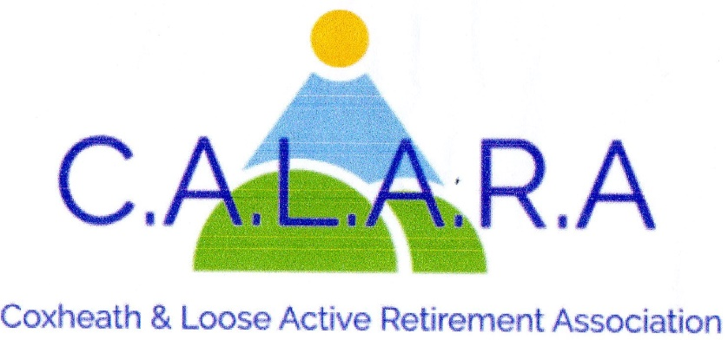
www.calara.org.uk

CALARA NEWSLETTER MAY 2024

TODAYS ENTERTAINER-
Lucy Allen will entertain us with a talk 'Highs and Lows of a Stuntwoman's Life.'

MEMBERSHIP- Chris Coleman
If you were not at last month’s meeting can you see Chris in the small hall in the tea break with your completed form and money(£5) for the year.
If you paid your membership last month can you collect your new membership card from Chris.

ART AND CRAFT- Chris Coleman. 2nd 3rd and 4th Fridays 2pm-4pm.
Art- We are still very short on numbers for the Art class. I am aware that we are without a tutor at present but I am doing what I can to get someone. Any Suggestions?
Craft- The craft class continues to grow slowly, we do have a pleasant afternoon with tea and biscuits as well as a natter around 3pm as well as doing our crafting work.
Don't forget to come and look at our new hand-made cards. They are as good as any shop bought ones.
If you require cards during the month you can always come along any Friday afternoon during the craft class to purchase them. We use the North door for security reasons.

SHORT MAT BOWLS – Chris Frost Tuesday afternoons.
The bowls group meet on Tuesday afternoons between 2.45-5.00pm.
Chris Frost-01622 745908

ELASTIX- Barbara Lowe- Monday mornings.
The Elastix exercise class meet in the small hall on Monday mornings. There are 2 classes at 10.00am and 11.00am
Barbara Lowe- 01622 296863

CRIBBAGE- Gwen Hawkes- Monday afternoons.
We meet in the Committee room on Monday afternoons from 2.00pm-4.00pm. The cost is £2 including refreshments.
Gwen Hawkes- 01622 746847.

WHIST-Gwen Hawkws- Wednesday afternoons.
We meet in the Committee room on Wednesday afternoons 1.00pm-3.30pm. The cost is £3.50 to cover refreshments,,raffle and Whist prizes. Contact Gwen Hawkes 01622 746847.

SOLITAIRE- Sheila Rosier
We are a friendly group for members on their own. We meet on 2nd Tuesday of the month for a cup of tea and a chat. Sheila Rosier 01622 746459.

LUNCHES- Sheila Scott
Our next lunch will be at Papa's Fish Barn in Aylesford on Thursday May 30th at the usual time of 12.30. Please put your name down at the tea-break to avoid disappointment. Next month I hope to have a new venue for us. Something to look forward to! Sheila Scott 07443 394615.

HOLIDAYS – Cliff Burke.
With regards to our holiday to Cricket St Thomas in Somerset on 8th July, all monies are now in and the bill is being paid. All special requests have been registered and confirmed.
The day trips will probably comprise a visit to the Fleet Air Arm museum, the Seaton Tramway, Dorchester Market and Lyme Regis.
We are just confirming bookings and further details will follow when it is all arranged and slight alterations may be made.

OUTINGS- Carole Burke.
Tenterden Steam Railway-Thursday 23rd May the cost will be £50 (with a minimum of 40 people). This will include coach,travel and a ploughman's lunch, with free time at the Tenterden Railway shop/museum and time in Tenterden for coffee etc. Full payment in cash or cheque required please by today's meeting during the tea break. Spaces are still available. Carole 07736 104674.
We now have final confirmation to the trip to Battersea Power Station-Thursday 12th September. Depending on numbers the cost will be £20-£25 with an optional extra cost of £15.30 to take the lift
to the top of the chimney with its stunning views. There is disabled access. A deposit of £10 will be collected next month.

INVITATION TO JOIN LOCAL WALKS.
Two of our members are involved in running 'Health Walks' which were based originally from the doctors surgery. We have been invited to join them. The details are.
'Our walks are on the 2nd and 4th Friday of the month,meeting at the Village Hall 9.50 for 10.00am start. These walks are between 1-1.5 hrs long,this depends on the ability of the attendees as we adjust each walk to who turns up on the day. We will split into two groups if we are both there,into faster and slower groups. We walk on footpaths so suitable footwear is needed. These are Free for Health walks run by local Council via' Ramblers Wellbeing walks'.
This would not be run by Calara but it was agreed we would support the invitation by putting an item in the newsletter and announcing it at the next meeting.

NEXT MONTHS MEETING-Friday 7th June.
Gehad Homsey will be telling us about 'Mercy Ships' this was postponed from this month. These are a charity based organisation that basically sail down the West Coast of Africa administering vital medical care to those in need. It is a fascinating and moving talk,they charge no fee so any voluntary donation is acceptable(but not compulsory)-------

